**eSamudaay local ecomm -Yourstory**

**Vocal for local: This tech startup wants to help build a community of local ecommerce networks**

[yourstory.com](https://yourstory.com/2020/11/vocal-for-local-tech-startup-esamudaay-ecommerce?utm_source=Email&utm_medium=YourStoryBuzz&__sta=vhg.hhksexQJekqoc%7CQIQV&__stm_medium=email&__stm_source=smartech)

Thimmaya Poojary

5-6 minutes

As India gears up to fulfil the vision of becoming **Aatmanirbhar**, ensuring self-sufficiency to address demand locally has become crucial. Today, small businesses are slowly realising the power of technology and how going digital will impact their sales and marketing.

To bring the benefits of digital solutions to local communities in the most easy manner, where local ecommerce can flourish and build networks of their own, **Anup Pai** started **eSamudaay** in July this year along with **Ravinder Mahori** and **Ravi Haldipur**.

The technology platform is similar to a plug-and-play system to foster entrepreneurship and create an **ecommerce network between sellers and buyers in smaller towns** without the top down approach of a large company.

The Bengaluru-based startup is now operational in the temple of town of Udupi in Karnataka with about 50 sellers on board, and claims to be adding about 10 sellers every week.

**Decentralisation**

A technologist, second-time entrepreneur, and an angel investor, **Anup** had previously co-founded a technology startup called Fintellix Solutions focused on the financial services industry, which was later acquired by Nasdaq-listed Verisk Analytics in 2017.

During this time, Anup travelled across the world and gained several insights on the evolving nature of technology and how it could be used to strengthen the bonds of a community.

“I spent a major part of my time around centralisation, but here was a shift happening towards decentralisation where the power of technology could reach the smaller guys,” says Anup.

eSamudaay was founded to allow people to build their businesses using its technology platform.

**To begin with, the startup is offering ecommerce applications for local communities through its platform.**

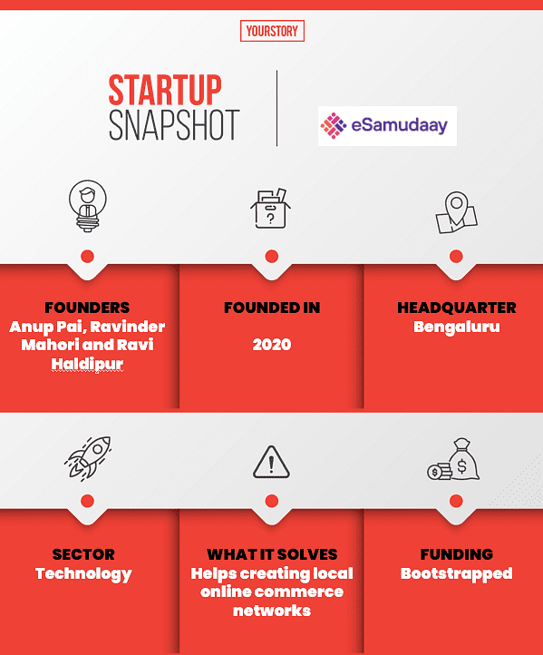

Anup describes eSamudaay’s technology platform as a business in a box. There is a core software desktop application, which is a combination of business intelligence, data analytics, and enterprise management.

The startup then provides the APIs of the platform where any entrepreneur can use it to build various business applications. It can be used to digitise the inventory of small kirana stores, it can carry out transactions, and also allow payments.

Anup strongly believes that India is going through a strong digital adoption spike, and the COVID-19 pandemic has actually accelerated the process.

**How it works?**

The local entrepreneur who signs up with eSamudaay can digitise the inventory of the seller using a mobile interface and also bring in buyers or consumers. Besides this, they can also create a delivery team to fulfil any kind of ecommerce transaction.

“Our platform can be used by a person to organise the community, digitise the merchants, and to get consumers on board. It becomes a trusted community platform,” says Anup.

Anup believes that the long term sustenance of a community is possible where the producers - be it the small shopkeeper, merchant, or farmers, are empowered with digital tools to connect with the consumer. This is akin to building a hyperlocal ecommerce network where one circle connects with the other.

“There are digital tools which are widely available and we are here to help build these applications easily to start quickly,” says Anup.

“An end consumer can download the app and check what is available within his or her local circles,” says Anup.



eSamudaay co-founder Ravi Haldipur

Anup has been networking within his circles, which includes his peers, colleges, and incubation networks to expand the technology platform of the startup. It has also made headway in places in Bellary in Karnataka and Nashik in Maharashtra.

The ecommerce enabler platform is available in nine Indian languages at present.

**Future plans**

Anup is very clear that this model will work, as he believes in high degree of transparency as there is a lot of data involved. “We consider ourselves as responsible data stewards and believe in protecting the information privacy of any individual,” he says.

As of now, the business model of eSamudaay works on the software as a service (SaaS) subscription model, and includes certain commissions. As part of its future plan, the startup is looking at opening its platform for lending service providers and also for advertising.

At the same time, there are large ecommerce companies like Flipkart, Amazon, and JioMart, which are also taking steps to reach out to smaller merchants. However, Anup is of the firm belief that ecommerce has not really reached to the wider section of the population.

“My focus is on the non-digitised population, which is a large addressable market. If we do a good job, the power of entrepreneur and spirit of India will wake up,” says Anup.

The founder of eSamudaay says there is a long way to go before the concept of local ecommerce takes firm roots through building strong community networks.

“This (local ecommerce networks) bodes well for the long term as there is pride in being part of your community,” says Anup.